Downspout Planter
MAINTENANCE GUIDE
phillywatersheds.org/raincheck

General Maintenance Checklist
- Water vegetation immediately after planting and weekly during initial establishment if it does not rain.

- If plants appear to be wilting, water 2-3 times per week until they return to good health.

- Keep the overﬂow cap (atrium grate) free and clear of debris such as dead leaves or trash. Check it after storms. Keep soil and debris off of the top of the stone mulch so ﬂoatable material does not clog the overﬂow device.
- Remove weeds as needed.
- Check drainage of box after rainstorms to make sure that the box drains and/or water evaporates within 24 hours. If water is not draining, ensure that the underdrain valve is open sufﬁciently.
- Check the downspout connection (diverter or downspout elbow) to the box to ensure it has not been disconnected.
- Inspect plants to evaluate health and replace if necessary.
- Cut back or remove dead vegetation in fall.
- Check to ensure that roof gutters leading to the downspout are free of leaves and other debris.
- Check to ensure that downspout leading to the planter is properly connected to roof gutter.
- In wintertime, check to make sure that overﬂow is clear of debris and snow. Periodically inspect planter to ensure ice is not accumulating.

Downspout Planter Diagram
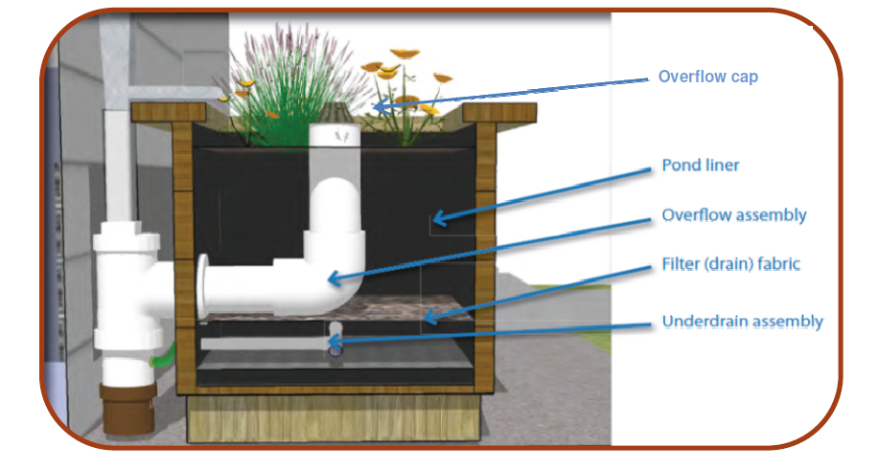

Potential Maintenance Concerns
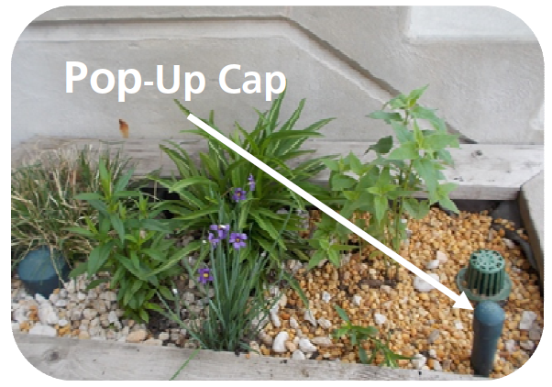
My planter box is full of water and is not draining:
- First, check the outlet and make sure the spigot is turned on allowing water to drain from the underdrain.
- If open and water is still not draining, remove the pop-up cap from the underdrain and ﬂush water down it using a hose or gallons of water; this should dislodge any debris that may be clogging it.
- If temperatures are below freezing, ice may be present in the underdrain. Wait for it to thaw and re-check.

The soil in my downspout planter is getting washed away or is settling
- Settling and scouring are issues that commonly occur after heavy rain storms. To replace or add soil to your planter box, use a 5 gallon bucket to make a soil mix containing 60% sand, 10% topsoil, and 30% compost.
- If soil is getting washed away where the downspout is connected to the planter box, add large gravel or river rock to the area to help slow down the water.

